**Context**

The data appear to show considerable variation and autocorrelation, even after taking the natural log of the California unemployment rate.



It is worth noting that the regression results did not differ significantly when using logged unemployment rates vs. the rates themselves, but I have included only models that fit the logged variable below.

**Results and Tests of Normal Independent Distribution**

I found that an ARIMA(1, 0, 1) model best fit the data. This model had the highest log likelihood of all the models I tested and returned a very low standard error of the mean, as you can see in the table on the following page.

It is worth noting, however, that the AR coefficient is close to 1, indicating there may be a problem with nonstationarity (i.e., that time effects variation in the data). Furthermore, the Dickey-Fuller and Phillips-Perron tests both indicated this problem may exist.

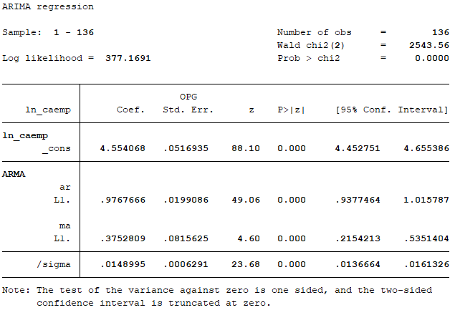

I also performed a Portmanteau test for white noise on the models residuals, which indicated the model is appropriate. Additionally, the correlogram and partial correlogram both indicated that the autocorrelations and the partial autocorrelations of the residuals entirely fell within the bounds of the 95 percent confidence interval bounds. This model also returned the lowest AIC and BIC values.



Finally, I tested the forecast accuracy of each model by computing the mean forecast error and mean absolute deviation. In both instances, I subtracted the predicted values from the actual values—taking the absolute value in the second instance—and dividing by the number of observations to assess the amount of variance. This model had the highest forecast accuracy of those I tested.

